-Baraay placenames DRAFT

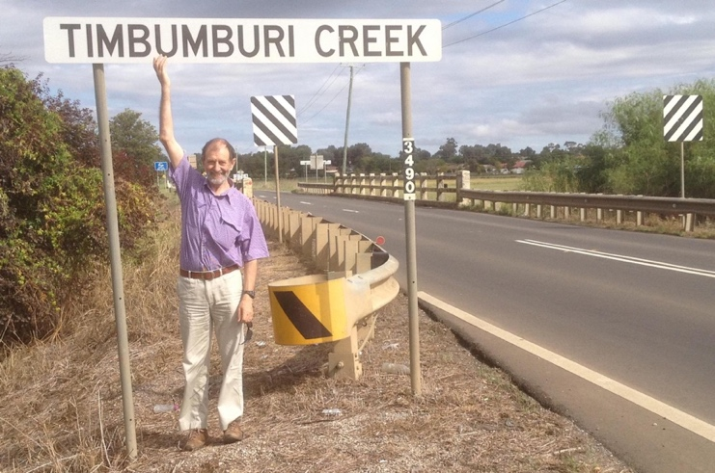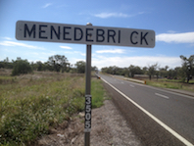
Two creeks near Tamworth, the first, dhimba-m-baraay, ‘sheep-with’, the second with menede.

Yaama,
I am compiling a list of placenames in Gamilaraay country that may include the Gamilaraay suffix -Baraay, ‘with, having’. The suffix is ‑baraay, except after words which end in l and rr, when it is -araay. It has been written many ways, in places mainly as -bri and -eroi, but also as -mbri, -bry, -mburi -eroy, -aroy, -iroy, -aroi, -oroi and perhaps in other ways. The first a in ‑Baraay was often not heard by wandas. The ‘i’ in -bri and -buri is pronounced like ‘i’ in Bondi, not as in ‘pit’.
Below is a list of names I have found. Not all variations of a name are included. People wrote words in the spelling system they knew, mostly English, and often did not hear sounds differences that matter in Gamilaraay (e.g. d/dh, n/ng) but heard differences that matter in English but not in Gamilaraay: using the sounds written in English g or k made no difference to the meaning of a Gamilaraay/Kamilaroi word. Kamilaroi, Gamilaroi and Gamilaraay are all variant spellings of the one word. aay in current Gamilaraay spelling can be pronounced like ‘I, eye’ or ‘oi/oy’ and sometimes is heard as ‘ay’.
The list of names below does not include the most common use of the suffix, in the name Gamilaraay (gamil ‘no’) except in Comilaroy Weir.
The meanings of a few of the names are given after the list of names, with some further information.
If you know of other places in Gamilaraay country that include the suffix I would very much appreciate it if you can let me know. If you find the place on Google maps please also send the latitude and longitude. I plan to write something longer on the topic eventually.
John Giacon. jgiacon@ozemail.com.au

Draft version of map: GR Country
https://www.google.com/maps/@-29.3755862,147.0556807,6z/data=!4m2!6m1!1s101MK1Q8WffC-Y9_8mieFiiUuuKMoee0R

Draft version of map: non-GR Country
https://www.google.com/maps/d/u/0/edit?hl=en&mid=1QShOWq3QdR3SeRIiwcZlaKcU53-rIgSi&ll=-30.670386660741734%2C148.70000000000005&z=5

Placenames
in Gamilaraay country likely to include -Baraay
(as at 2019-09-21)
NSW
Beanbri
Benelabri
Bibleroy Creek
Billeroy
Boggabri
Bullaroy
Bulliroy Creek
Bulyeroi
Buriembri
Carbeenbri
Collarenebri
Collaroy
Comilaroy Weir
Comleroi
Cuttabri
Denebry
Denuleroi
Dimberoy Hill
Edgeroi
Gineroi
Goonbri
Gundibri
Kamilaroi
Keelibri Tank
Kenebri
Komleroi
Koolbury
Limbri
Menedebri Creek
Milroy
Mollieroi
Molroy
Momberoi Gully
Narrabri
Neerealleroi
Noggabri
Pindaroi
Polidoroi Lagoon
Queerbri
Quottabri
Tackinbri
Tareelaroi Weir
Therribri
Timbumburi
Uarbry
Ulamambri
Umbri
Wigelroy Lagoon
Yaleroi
QLD
Booberoi
Ginnabri

Meanings and discussion
The meanings of a few names are known. Some are listed below. The first set of meaning are from Ridley (1875), given with the current spelling, Ridley’s interpretation, and some notes.

Bukkiberaī (Boggabry) [bagay-baraay] ‘place of creeks’ (now written Boggabri)
Murrowolarai (Molroy) [marrawal-araay] ‘having hedgehogs (echidnas) (murrowol)’
Ngurraburai (ngarrabry) [nharra??-baraay nhaarra ???] ‘having forks’?? (Narrabri).
Kolorīnbrai [Galariinbaraay , Collarenebri] ‘abounding in kolorīn, the flowers of the kuluba tree’
Tarīlarai [dhariil-araay] ‘having reeds’
Yarrularai (commonly called Yalaroi) [yarral-araay] ‘having stones’.

Ridley has one name which I have not found on current maps:
Wolobrai [uncertain + –baraay ; cf. walan ‘hard’] ‘stony (in the Wiraiarai dialect).
He also has the suffix in a man’s name:
Tarunderai" [possibly dharra ‘thigh’ +-baraay] (great legs and arms)

Another name whose meaning is clear is Timbumburi, dhimba-m-baraay ‘sheep-m-having’ (using t or d made no difference to meaning in Gamilaraay). The -m before -b is not common in Gamilaraay, but is found in Wangaaybuwan and Wayilwan. (If you like using linguistic language you can call m-b a pre-nasalised stop.)

Below is speculation about the meanings of other names.
Bibleroy bibil ‘bimble box tree’
Carbeenbri gaabiin ‘Carbeen tree’
Gundibri gundhi ‘stringybark tree’ and so ‘house’
Keelibri giil ‘urine’ (verb is giili-y)

There are a number of languages whose name includes ‘no’ and the ‘with/having’ suffix: Yuwaalaraay, Yuwaalayaay (which had Yuwaal as ‘no, but now use waal, and a slightly changed form of the suffix, -Bayaay) Wiradjuri, Wangaaybuwan and Wayilwan (Wirraay, Wangaay and Wayil all ‘no’) The Wiradjuri suffixe is -Dhurray/-Dhurraay, often written as -dra, less commonly as -dry and with a range of other interpretations including djuri in the language name (see the Nash article). The Wangaaybuwan/Wayilwan suffix is -buwan-wan, often written as -bone.

Placenames which may include -Baraay,
but are not in Gamilaraay country.

Bri bri
Condabri
Dazobri
Jabindabri
Narrabri
Nellybri
Windibri
Maybury Peace Park
Big Burrumbury Creek
Badbury Creek
Bebri
Booberoi
Bullaroy
Bulliroy Creek
Callubri
Carabury Creek
Collaroy
Comlaroi
Comleroy
Dellateroy Creek
Edgeroi
Edgeroi
Goonaroi Ridge
Mickibri
Milroy
Narrabri Swamp
Pomeroy
Tuckelbri
Wallaroi
Wongabri Creek

Some are more likely to be of Gamilaraay origin than others. If the final three letters are -bri or -roi it is more likely that the name is of Gamilaraay origin. In fact some of these names are the same as names on Gamilaraay country, for instance Narrabri and Edgeroi, so very likely borrowings.
There are quite a few placenames that end in -bury. It seems unlikely that these are of Gamilaraay origin, with few such names in the GR area and many outside it.
The ending of some names suggests possible GR origin, for instance Sprilbury, but the spr combination is highly unlikely to be of Gamilaraay origin.

